21 June 2016

**.....................**

**......................**

**.......................**

Dear ..............

Thank you for your recent enquiry regarding Cherry Picker Ltd access machinery. Please find enclosed the details of **............................................** .

Meanwhile if you have any further inquiries regarding access machinery please don’t hesitate to contact me anytime, I would be happy to assist you.

## Brief Cherry Picker Ltd History.

Since 1992 Cherry Picker Ltd has been Ireland’s leading Sales Company for **ALL** makes and models of Access Machinery, supplying access solutions right across Irish Industry.

Cherry Picker Ltd is the only independent access company in Ireland that can supply **Truck, Track and Trailer Mounted Platforms, a full range of Self Propelled Scissors and Boom Lifts.**

Cherry Picker Ltd. also provides **Service** and **Spare Pa**rts for all makes and models of access machinery.

The dedicated **Spare Parts** department can provide any part required for any access platform, with most parts guaranteed for next day delivery.

We look forward to hearing from you.

Best Regards,

Alan Brodigan

Sales Dept

Mobile 086 255 7755

elevah logo **47 picking**

**Compact. Versatile. Practical**

Elevah 47 is the automatic ladder for working at height up to 4.60 m.

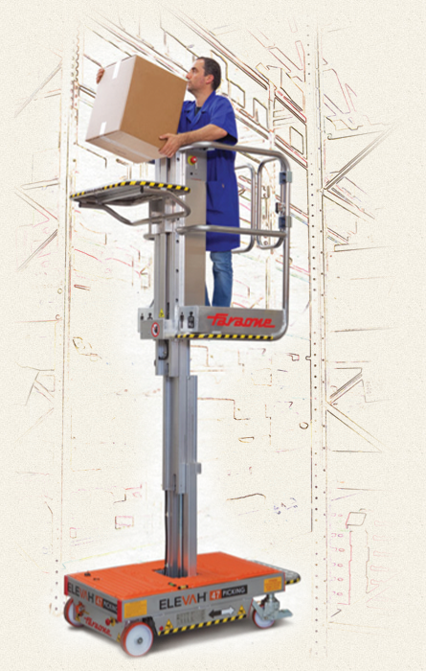

**PRACTICAL AND HANDY**

Thanks to its reduced weight Elevah 47

moves easily with a push of max 8 kg.

Ascent and descent

with MAXIMUM SIMPLICITY

and safety. Automatic lock

of the wheel during lifting

Since the platform guardrails can be

removed, the scissor lift

can access

very reduce spaces.

MAXIMUM EASINES

The operator can climb easily

thanks to the easy opening

of the basket.

Ascent and descent

with maximum simplicity

and safety. Automatic lock

of the wheel during lifting.

Practical PICKING platform

The load floor is electrically driven

and it can be brought to

the desired height with a simple button.

**Technical Data Sheet ELEVAH 45 Picking**

|  |  |
| --- | --- |
| **Lift capacity** | **200 KG** |
| **Operators** | **1** |
| **Use** | **internal** |
| **Tray capacity picking** | **100 Kg.** |
| **Machine weight** | **260 Kg.** |
| **Power source** | **24V** |
| **12 v Batteries - 44 Ah x 2** | **gel** |
| **Battery charger** | **110V-220V** |
| **Idle wheels dimensions** | **Ø 150 x 45** |
| **Turning wheels dimensions** | **Ø 200 x 50** |
| **Max. lifting speed** | **0,20 m/s** |
| **Max. lowering speed** | **0,15 m/s** |
| **Manual force to move it** | **8 Kg.** |
| **Manual force once in motion** | **5 Kg.** |



**Features ELEVAH 45 Picking**





*Save money – 50% labour cost*

*Save time*

*Save effort*

*MAXIMUM SAFTY*

Easy climb

Adjust the high in seconds with a button

Automatic lock of the wheel

Open basket – Easy operation.

It moves easily with a push of max 8k